
YEAR 12 Essentials Mathematics
Semester 2 2018
Investigation 3 – Compound interest

Total Marks: ______ / 22 marks
Name: ______________________ Total Time: 55 minutes

Full working out must be shown to get full marks.

Attempt all questions

Resources allowed:

1 A4 page, (1 side) of hand written notes, ruler, calculator

Through hard work and a careful savings strategy Stevie and Macca have accumulated $10,000 each with which they are buying a car.
Stevie’s car Macca’s car
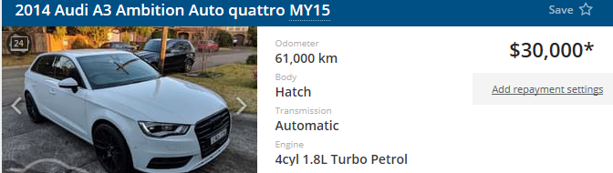
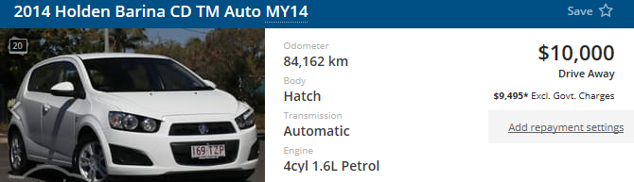
Q1) Macca does not have enough savings to afford car 2 so he will need to organise finance using a 5 year loan for the extra money that he will need. Using the comparison rate below, calculate the total cost of purchasing the $30,000 car if the loan is compounded monthly (answer to 2 d.p.)



2 Marks
Q2) Macca will need to ensure he pays back the total cost over the 5 years. Calculate how much he will need to pay fortnightly in order to pay off the total cost. (26 fortnights in a year - answer to 2 d.p.)

1 Mark

Q3) Unlike bank accounts that gain value over time, cars lose value over time. We call this reverse interest “depreciation”.
Use the formula below to calculate the amount of money each car loses over 5 years if each car loses 10% of its value each year.
- the formula for depreciation is D = P(1 - $\frac{r}{n})^{t}$.

Stevie’s car:

2 Marks
Macca’s Car:

2 Marks

Use the answers above to fill in the able below.
 | Stevie’s car | Macca’s car
Initial value
Total cost of purchase
Car’s value after 5 years
Total cost – Cars current value =
2 Marks
Q4) From his regular pay, Stevie is able to save $500 per fortnight, how much is this per year?

1 Marks

Q5) Originally Macca was able to save the same amount as Stevie each fortnight, but now he also needs to pay back his car loan. How much will Macca now be able to save per annum? (saving – repayment)

2 Marks

Q6) Over the 5 years that Macca has the loan, how much more will Stevie be able to save than Macca?

2 Marks

Q7) Stevie and Macca decide to invest their 5 year savings into two different accounts. Stevie invests in a 5% compounding account for 10 years (compounded monthly). Macca invests in a 6.5% simple interest account. What would be the end value of their respective accounts (answer to 2 d.p.)?
Stevie

2 Marks

Macca

2 Marks

Q8) From when Macca and Stevie bought their cars to now, who has made better finical decisions? Comment on their total wealth, savings, and investment choices.

4 Marks

End of Investigation

